|  |
| --- |
| SOLAR PV MPPT SYSTEM |

|  |  |
| --- | --- |
|  |  |

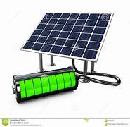

|  |
| --- |
| PROJECT REPORT |



Presented by :

1] Suyog Jayavant Kale

SY B.Tech - Electronics & Telecommunication

Government College of Engineering, Karad.

|  |
| --- |
|  |

1] Introduction of MPPT

2] Solar panel system using MPPT

3] Working principle

4] System model using MATLAB

5] Algorithm code

6] Simulation result

7] Conclusion

8] References

|  |
| --- |
| CONTENTS |

|  |  |
| --- | --- |
| Introduction of MPPT -  MPPT means the Maximum Power Point Tracking is algorithm that included in charge controllers used for extracting maximum available power from PV module under certain conditions.    Thevoltage at which PV module can produce maximum power is called maximum power point (or peak power voltage).  Maximum power varies with solar radiation, ambient temperature and solar cell temperature. |  |
| .   * We have familiar with solar PV power plant installation process, we know the components that are used in the system. * We set up the solar panel on the rooftop of the homes or a solar PV power plant in huge area for the industrial purpose. * The radiations from the sun are come on the earth & strikes on the solar cells of the solar panel. * That sunlight or radiations are absorbed by panel then process of electricity generation started after that charge controller is used along with battery bank, that generated electricity pass through these and transfer to inverter. * Inverter converts that power or energy from dc to ac and pass towards power metering part * from this some amount of generated electricity goes to electric grid and remaining supplies to home appliances. * As this way flow of solar PV power plant works and produce electricity efficiently without disturbing environmental balance which is good thing. |

MPPT charge controllers should be used on all higher power systems using two or more solar panels in series, or whenever the panel operating voltage (Vmp) is 8V or higher than the battery voltage.

Solar PV with MPPT -

Using this clever technology, MPPT solar charge controllers can be up to 30% more efficient, depending on the battery and operating voltage (Vmp) of the solar panel.

As this we use MPPT as charge controller in solar PV system and makes working efficient.

* Working principle of MPPT –

Working Principle -

MPPT is DC to DC converter which operates by taking DC input from PV module, changing it to AC and converting it back to a different DC voltage and current to exactly match the PV module to the battery. Boost converter is power converter which DC input voltage is less than DC output voltage. DC to DC converter transfers maximum power from PV module to load.

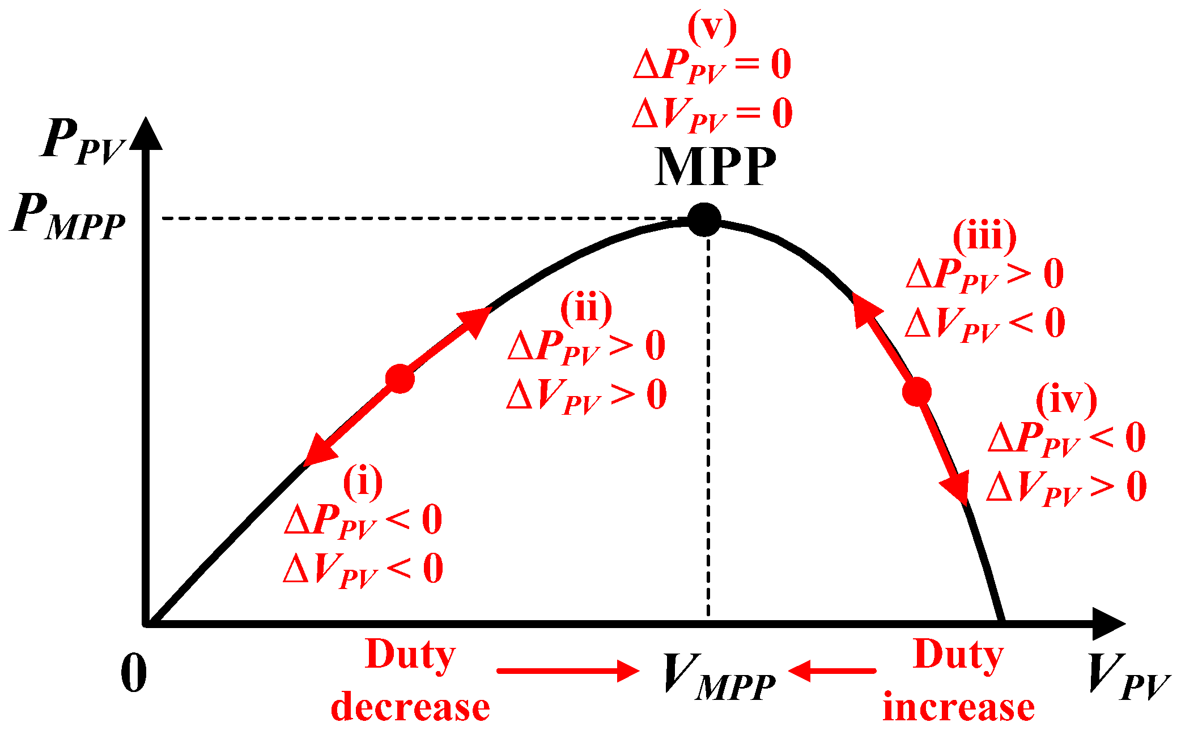

The MPPT charge controller ensures that the loads receive maximum current to be used (by quickly charging the battery). Maximum power point could be understood as an ideal voltage at which the maximum power is delivered to the loads, with minimum losses. This is also commonly referred to as peak power voltage.

MPPT is most effective under these conditions:

* Cold weather, cloudy or hazy days:- Normally, PV module works better at cold temperatures and MPPT is utilized to extract maximum power available from them.
* When battery is deeply discharged:- MPPT can extract more current and charge the battery if the state of charge in the battery is lowers.

Main features of MPPT solar charge controller

|  |
| --- |
| 1] In any applications which PV module is energy source, MPPT solar charge controller is used to correct for detecting the variations in the current-voltage characteristics of solar cell and shown by I-V curve. |
|  |
| 2] MPPT solar charge controller allows users to use PV module with a higher voltage output than operating voltage of battery system. For example, if PV module has to be placed far away from charge controller and battery, its wire size must be very large to reduce voltage drop. With a MPPT solar charge controller, users can wire PV module for 24 or 48 V (depending on charge controller and PV modules) and bring power into 12 or 24 V battery system. This means it reduces the wire size needed while retaining full output of PV module. |
| 3] MPPT solar charge controller reduces complexity of system while output of system is high efficiency. Additionally, it can be applied to use with more energy sources. Since PV output power is used to control DC-DC converter directly. |
| 4] MPPT solar charge controller can be applied to other renewable energy sources such as small water turbines, wind-power turbines, etc. |

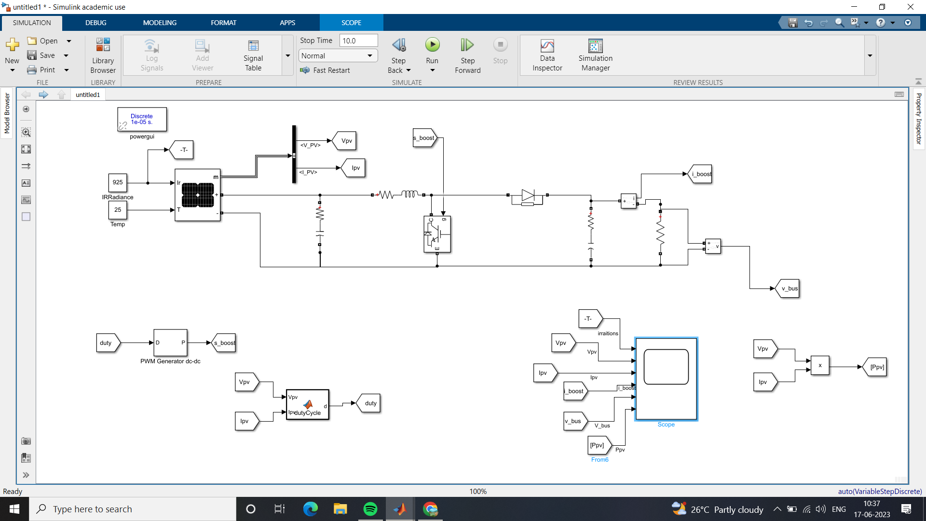

MATLAB/SIMULINK MODEL -

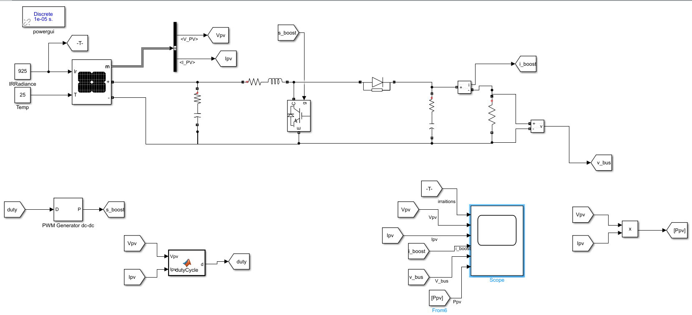

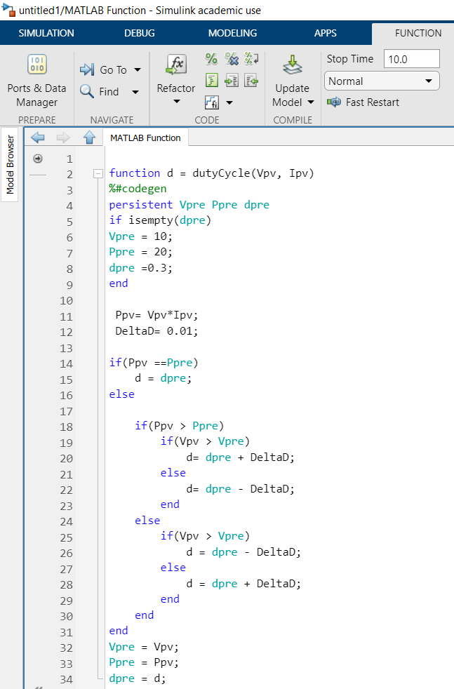

Algorithm code for functional block -

1] For radiations = 925 and temperature = 25 degree Celsius

SIMULATION Result -

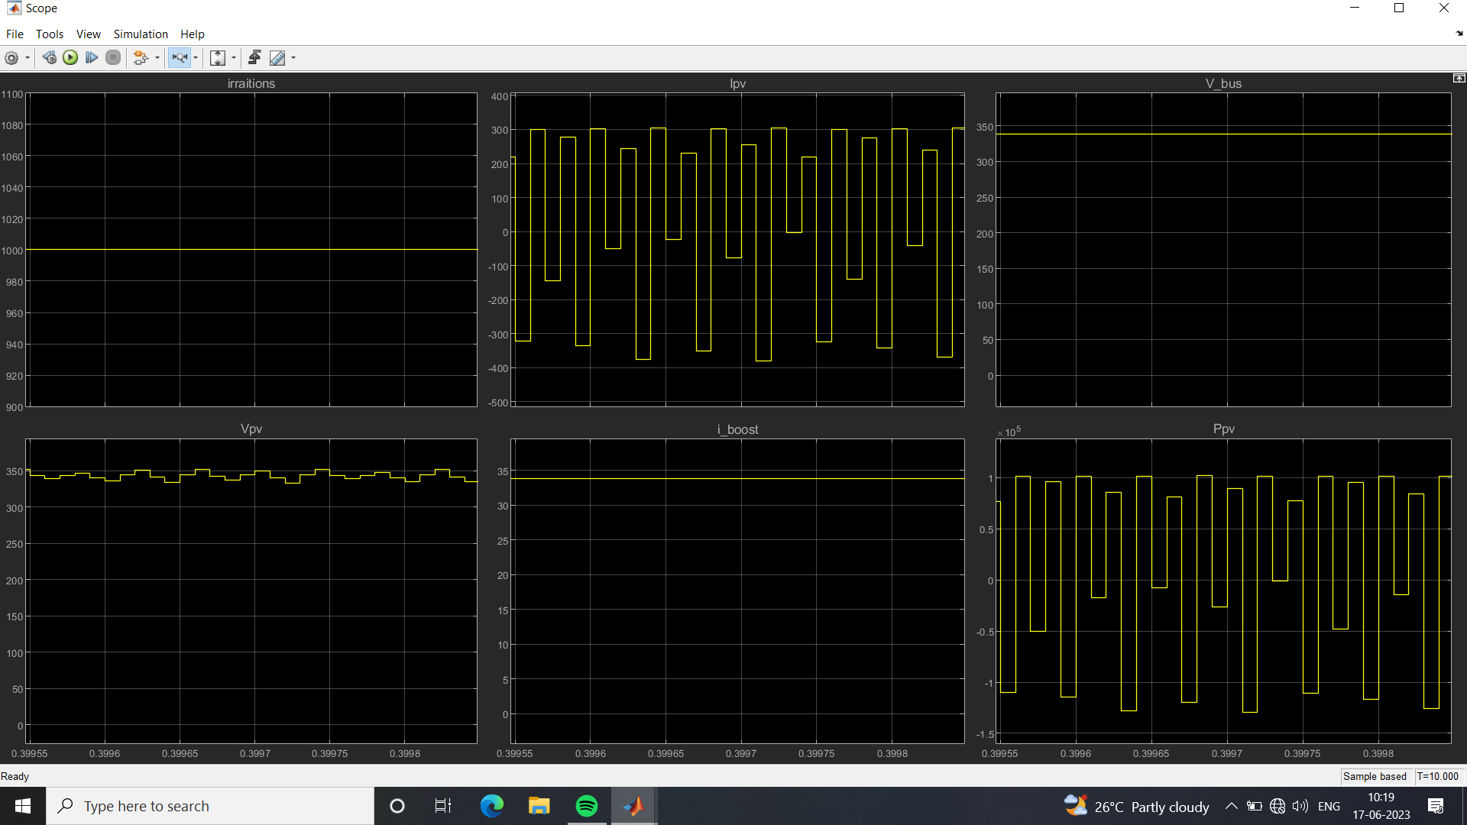

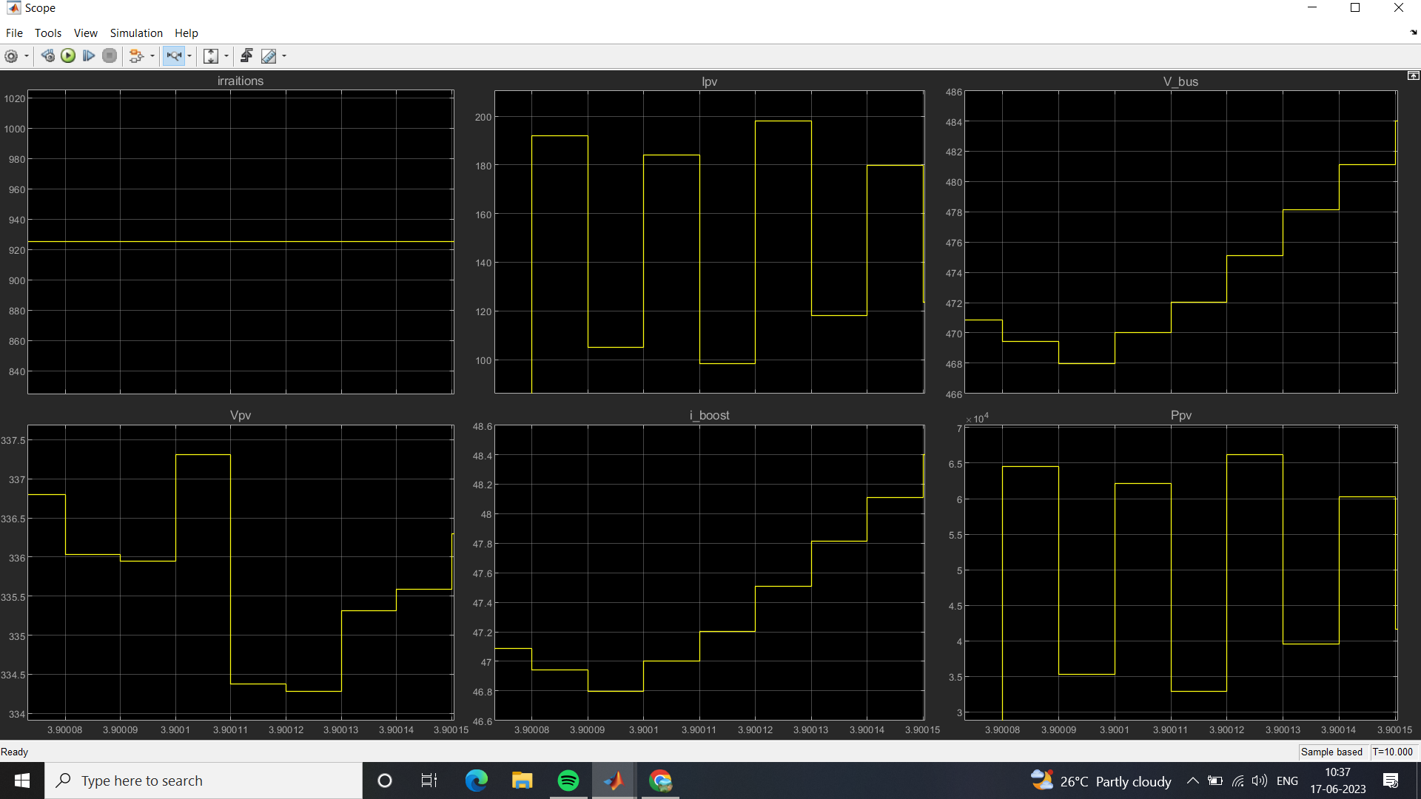

2] For radiations = 1035 and temperature = 25 degree Celsius

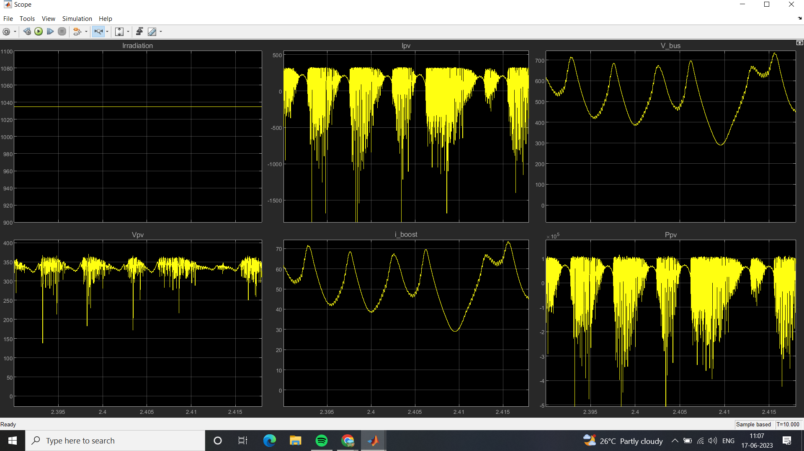

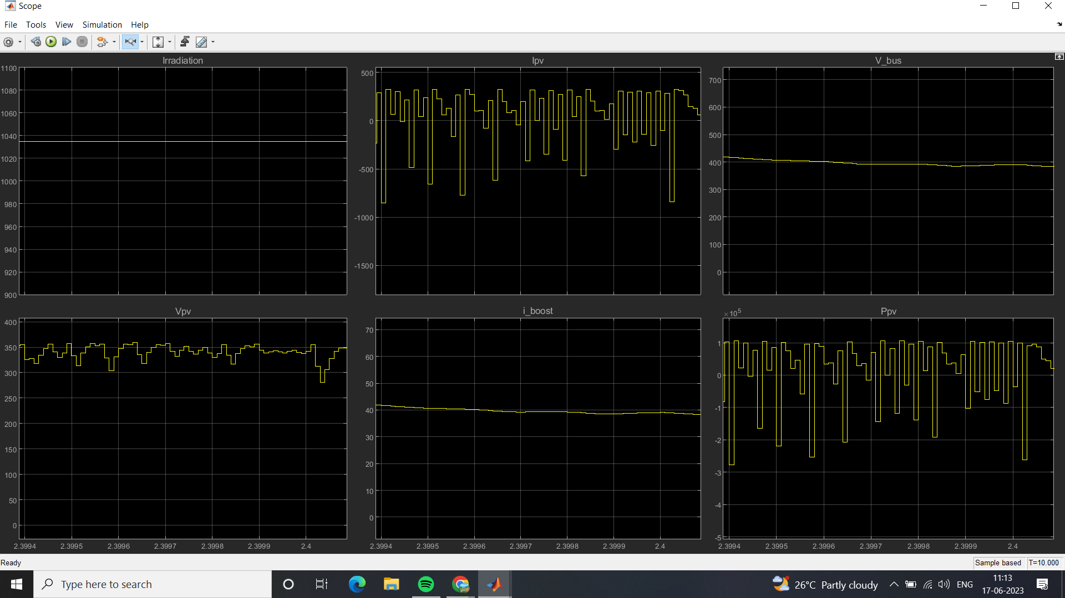

1] As we concluded that simulation result of model of solar PV MPPT system.

CONCLUSION -

2] We have understood the working principle of MPPT as charge controller and how does it helps to improve efficiency of solar panel for generating electricity.

3] We have also observed that simulation part of Power, Current, Voltage, Radiations according to input that has provided.

4] Observed the variations of graph and components of solar PV and understood the result.

5] As this way we have performed this project.

* <https://www.google.co.in/search?q=SOLAR+MPPT+PDF&authuser>

REFERENCES -

* <https://www.researchgate.net/publication/332226932_MPPT_Methods_for_Solar_PV_Systems_A_Critical_Review_Based_on_Tracking_Nature>
* <https://www.loomsolar.com/collections/solar-chargers-controllers>

* <https://www.victronenergy.com/upload/documents/Manual_SmartSolar_MPPT_75-10_up_to_100-20/29694-MPPT_solar_charger_manual-pdf-en.pdf>
* <https://www.cleanenergyreviews.info/blog/mppt-solar-charge-controllers>
* <https://www.youtube.com/watch?v=LMOmEppPS-Y>
* <https://www.researchgate.net/figure/Complete-Simulink-Model-of-Solar-PV-module-with-MPPT-algorithm_fig1_333703537>